R Statistics & Modeling

* R - Time Series Analysis
* R - Logistic Regression
* R - Normal Distribution
* R - Binomial Distribution

**R - Time Series Analysis**

Time series is a series of data points in which each data point is associated with a timestamp. A simple example is the price of a stock in the stock market at different points of time on a given day. Another example is the amount of rainfall in a region at different months of the year. R language uses many functions to create, manipulate and plot the time series data. The data for the time series is stored in an R object called **time-series object**. It is also a R data object like a vector or data frame.

The time series object is created by using the **ts()** function.

Syntax

The basic syntax for **ts()** function in time series analysis is −

timeseries.object.name <- ts(data, start, end, frequency)

Following is the description of the parameters used −

* **data** is a vector or matrix containing the values used in the time series.
* **start** specifies the start time for the first observation in time series.
* **end** specifies the end time for the last observation in time series.
* **frequency** specifies the number of observations per unit time.

Except the parameter "data" all other parameters are optional.

Example

Consider the annual rainfall details at a place starting from January 2012. We create an R time series object for a period of 12 months and plot it.

# Get the data points in form of a R vector.

rainfall <- c(799,1174.8,865.1,1334.6,635.4,918.5,685.5,998.6,784.2,985,882.8,1071)

# Convert it to a time series object.

rainfall.timeseries <- ts(rainfall,start = c(2012,1),frequency = 12)

# Print the timeseries data.

print(rainfall.timeseries)

# Give the chart file a name.

png(file = "rainfall.png")

# Plot a graph of the time series.

plot(rainfall.timeseries)

# Save the file.

dev.off()

When we execute the above code, it produces the following result and chart −

Jan Feb Mar Apr May Jun Jul Aug Sep

2012 799.0 1174.8 865.1 1334.6 635.4 918.5 685.5 998.6 784.2

Oct Nov Dec

2012 985.0 882.8 1071.0

The Time series chart −

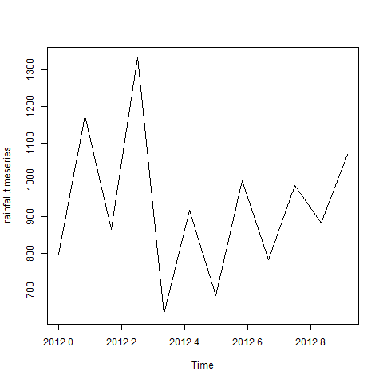

Different Time Intervals

The value of the **frequency** parameter in the ts() function decides the time intervals at which the data points are measured. A value of 12 indicates that the time series is for 12 months. Other values and its meaning is as below −

* **frequency = 12** pegs the data points for every month of a year.
* **frequency = 4** pegs the data points for every quarter of a year.
* **frequency = 6** pegs the data points for every 10 minutes of an hour.
* **frequency = 24*6** pegs the data points for every 10 minutes of a day.

**Multiple Time Series**

We can plot multiple time series in one chart by combining both the series into a matrix.

# Get the data points in form of a R vector.

rainfall1 <- c(799,1174.8,865.1,1334.6,635.4,918.5,685.5,998.6,784.2,985,882.8,1071)

rainfall2 <-

c(655,1306.9,1323.4,1172.2,562.2,824,822.4,1265.5,799.6,1105.6,1106.7,1337.8)

# Convert them to a matrix.

combined.rainfall <- matrix(c(rainfall1,rainfall2),nrow = 12)

# Convert it to a time series object.

rainfall.timeseries <- ts(combined.rainfall,start = c(2012,1),frequency = 12)

# Print the timeseries data.

print(rainfall.timeseries)

# Give the chart file a name.

png(file = "rainfall_combined.png")

# Plot a graph of the time series.

plot(rainfall.timeseries, main = "Multiple Time Series")

# Save the file.

dev.off()

When we execute the above code, it produces the following result and chart −

Series 1 Series 2

Jan 2012 799.0 655.0

Feb 2012 1174.8 1306.9

Mar 2012 865.1 1323.4

Apr 2012 1334.6 1172.2

May 2012 635.4 562.2

Jun 2012 918.5 824.0

Jul 2012 685.5 822.4

Aug 2012 998.6 1265.5

Sep 2012 784.2 799.6

Oct 2012 985.0 1105.6

Nov 2012 882.8 1106.7

Dec 2012 1071.0 1337.8

The Multiple Time series chart −

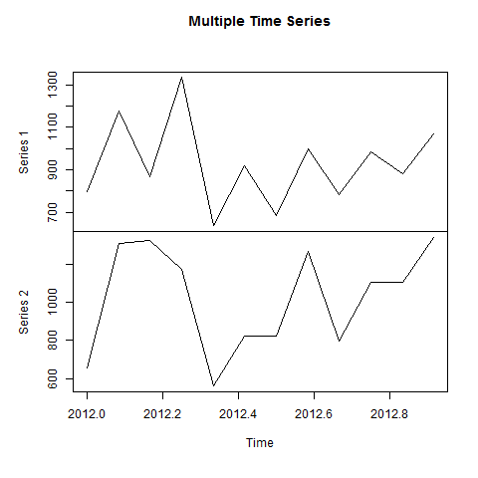

**R - Logistic Regression**

The Logistic Regression is a regression model in which the response variable (dependent variable) has categorical values such as True/False or 0/1. It actually measures the probability of a binary response as the value of response variable based on the mathematical equation relating it with the predictor variables.

The general mathematical equation for logistic regression is −

y = 1/(1+e^-(a+b1x1+b2x2+b3x3+...))

Following is the description of the parameters used −

* **y** is the response variable.
* **x** is the predictor variable.
* **a** and **b** are the coefficients which are numeric constants.

The function used to create the regression model is the **glm()** function.

Syntax

The basic syntax for **glm()** function in logistic regression is −

glm(formula,data,family)

Following is the description of the parameters used −

* **formula** is the symbol presenting the relationship between the variables.
* **data** is the data set giving the values of these variables.
* **family** is R object to specify the details of the model. It's value is binomial for logistic regression.

Example

The in-built data set "mtcars" describes different models of a car with their various engine specifications. In "mtcars" data set, the transmission mode (automatic or manual) is described by the column am which is a binary value (0 or 1). We can create a logistic regression model between the columns "am" and 3 other columns - hp, wt and cyl.

# Select some columns form mtcars.

input <- mtcars[,c("am","cyl","hp","wt")]

print(head(input))

When we execute the above code, it produces the following result −

am cyl hp wt

Mazda RX4 1 6 110 2.620

Mazda RX4 Wag 1 6 110 2.875

Datsun 710 1 4 93 2.320

Hornet 4 Drive 0 6 110 3.215

Hornet Sportabout 0 8 175 3.440

Valiant 0 6 105 3.460

Create Regression Model

We use the **glm()** function to create the regression model and get its summary for analysis.

input <- mtcars[,c("am","cyl","hp","wt")]

am.data = glm(formula = am ~ cyl + hp + wt, data = input, family = binomial)

print(summary(am.data))

When we execute the above code, it produces the following result −

Call:

glm(formula = am ~ cyl + hp + wt, family = binomial, data = input)

Deviance Residuals:

Min 1Q Median 3Q Max

-2.17272 -0.14907 -0.01464 0.14116 1.27641

Coefficients:

Estimate Std. Error z value Pr(>|z|)

(Intercept) 19.70288 8.11637 2.428 0.0152 *

cyl 0.48760 1.07162 0.455 0.6491

hp 0.03259 0.01886 1.728 0.0840 .

wt -9.14947 4.15332 -2.203 0.0276 *

---

Signif. codes: 0 ‘***’ 0.001 ‘**’ 0.01 ‘*’ 0.05 ‘.’ 0.1 ‘ ’ 1

(Dispersion parameter for binomial family taken to be 1)

Null deviance: 43.2297 on 31 degrees of freedom

Residual deviance: 9.8415 on 28 degrees of freedom

AIC: 17.841

Number of Fisher Scoring iterations: 8

Conclusion

In the summary as the p-value in the last column is more than 0.05 for the variables "cyl" and "hp", we consider them to be insignificant in contributing to the value of the variable "am". Only weight (wt) impacts the "am" value in this regression model.

**R - Normal Distribution**

In a random collection of data from independent sources, it is generally observed that the distribution of data is normal. Which means, on plotting a graph with the value of the variable in the horizontal axis and the count of the values in the vertical axis we get a bell shape curve. The center of the curve represents the mean of the data set. In the graph, fifty percent of values lie to the left of the mean and the other fifty percent lie to the right of the graph. This is referred as normal distribution in statistics.

R has four in built functions to generate normal distribution. They are described below.

dnorm(x, mean, sd)

pnorm(x, mean, sd)

qnorm(p, mean, sd)

rnorm(n, mean, sd)

Following is the description of the parameters used in above functions −

* **x** is a vector of numbers.
* **p** is a vector of probabilities.
* **n** is number of observations(sample size).
* **mean** is the mean value of the sample data. It's default value is zero.
* **sd** is the standard deviation. It's default value is 1.

dnorm()

This function gives height of the probability distribution at each point for a given mean and standard deviation.

# Create a sequence of numbers between -10 and 10 incrementing by 0.1.

x <- seq(-10, 10, by = .1)

# Choose the mean as 2.5 and standard deviation as 0.5.

y <- dnorm(x, mean = 2.5, sd = 0.5)

# Give the chart file a name.

png(file = "dnorm.png")

plot(x,y)

# Save the file.

dev.off()

When we execute the above code, it produces the following result −

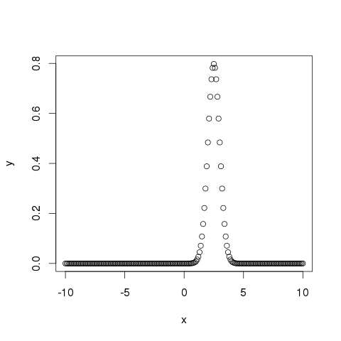

pnorm()

This function gives the probability of a normally distributed random number to be less that the value of a given number. It is also called "Cumulative Distribution Function".

# Create a sequence of numbers between -10 and 10 incrementing by 0.2.

x <- seq(-10,10,by = .2)

# Choose the mean as 2.5 and standard deviation as 2.

y <- pnorm(x, mean = 2.5, sd = 2)

# Give the chart file a name.

png(file = "pnorm.png")

# Plot the graph.

plot(x,y)

# Save the file.

dev.off()

When we execute the above code, it produces the following result −

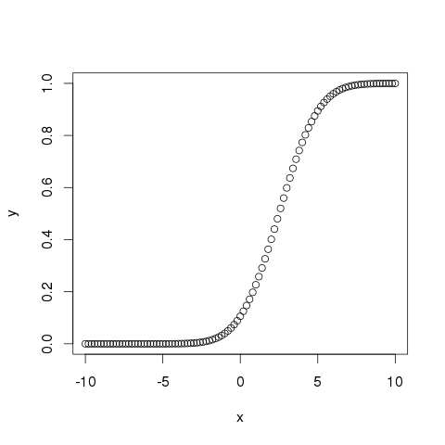

qnorm()

This function takes the probability value and gives a number whose cumulative value matches the probability value.

# Create a sequence of probability values incrementing by 0.02.

x <- seq(0, 1, by = 0.02)

# Choose the mean as 2 and standard deviation as 3.

y <- qnorm(x, mean = 2, sd = 1)

# Give the chart file a name.

png(file = "qnorm.png")

# Plot the graph.

plot(x,y)

# Save the file.

dev.off()

When we execute the above code, it produces the following result −

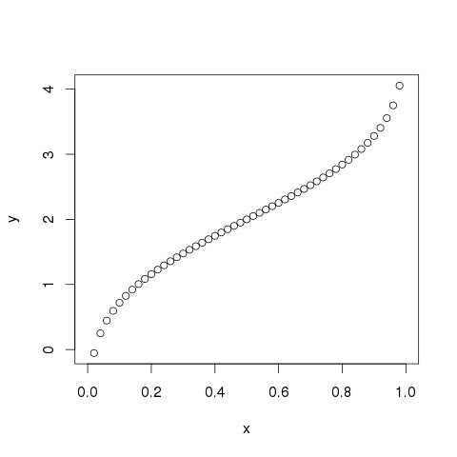

rnorm()

This function is used to generate random numbers whose distribution is normal. It takes the sample size as input and generates that many random numbers. We draw a histogram to show the distribution of the generated numbers.

# Create a sample of 50 numbers which are normally distributed.

y <- rnorm(50)

# Give the chart file a name.

png(file = "rnorm.png")

# Plot the histogram for this sample.

hist(y, main = "Normal DIstribution")

# Save the file.

dev.off()

When we execute the above code, it produces the following result −

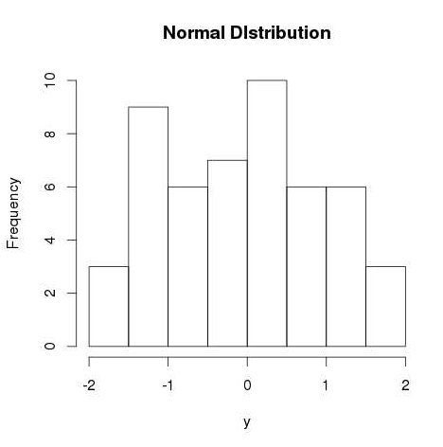

**R - Binomial Distribution**

The binomial distribution model deals with finding the probability of success of an event which has only two possible outcomes in a series of experiments. For example, tossing of a coin always gives a head or a tail. The probability of finding exactly 3 heads in tossing a coin repeatedly for 10 times is estimated during the binomial distribution.

R has four in-built functions to generate binomial distribution. They are described below.

dbinom(x, size, prob)

pbinom(x, size, prob)

qbinom(p, size, prob)

rbinom(n, size, prob)

Following is the description of the parameters used −

* **x** is a vector of numbers.
* **p** is a vector of probabilities.
* **n** is number of observations.
* **size** is the number of trials.
* **prob** is the probability of success of each trial.

dbinom()

This function gives the probability density distribution at each point.

# Create a sample of 50 numbers which are incremented by 1.

x <- seq(0,50,by = 1)

# Create the binomial distribution.

y <- dbinom(x,50,0.5)

# Give the chart file a name.

png(file = "dbinom.png")

# Plot the graph for this sample.

plot(x,y)

# Save the file.

dev.off()

When we execute the above code, it produces the following result −

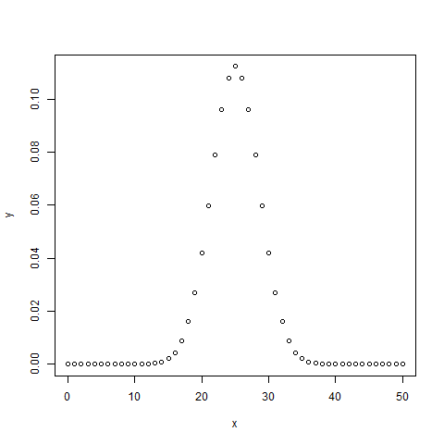

pbinom()

This function gives the cumulative probability of an event. It is a single value representing the probability.

# Probability of getting 26 or less heads from a 51 tosses of a coin.

x <- pbinom(26,51,0.5)

print(x)

When we execute the above code, it produces the following result −

[1] 0.610116

qbinom()

This function takes the probability value and gives a number whose cumulative value matches the probability value.

# How many heads will have a probability of 0.25 will come out when a coin is tossed 51 times.

x <- qbinom(0.25,51,1/2)

print(x)

When we execute the above code, it produces the following result −

[1] 23

rbinom()

This function generates required number of random values of given probability from a given sample.

# Find 8 random values from a sample of 150 with probability of 0.4.

x <- rbinom(8,150,.4)

print(x)

When we execute the above code, it produces the following result −

[1] 58 61 59 66 55 60 61 67